**AI ASSISTED CODING**

**LAB ASSIGNMENT – 4.3**

**SANGEETH THUMUGANTI**

**2403A53005**

**24BTCAICYB01-2-1**

Task Description#1  
● Zero-shot: Prompt AI to write a function that checks whether a given year is a leapyear.

Expected Output#1  
● AI-generated function with no examples provided

**PROMPT:**

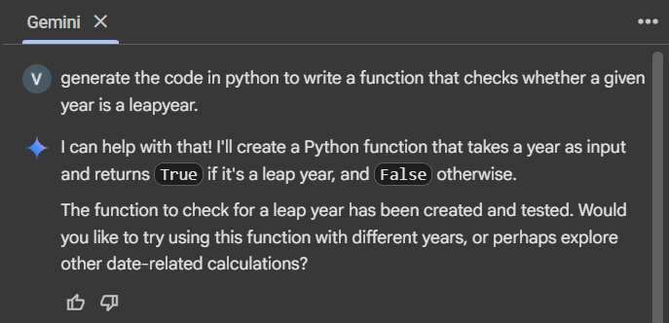

**CODE:**

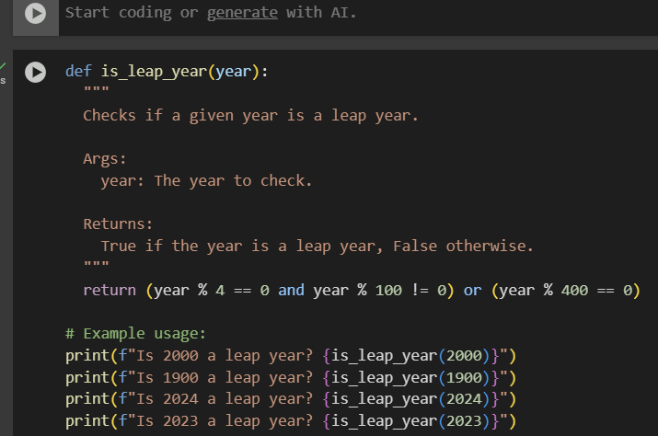

**OUTPUT:**

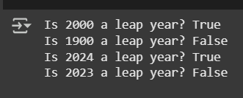

Task Description#2  
● One-shot: Give one input-output example to guide AI in writing a function thatconverts centimeters to inches.

Expected Output#2  
● Function with correct conversion logic.

**PROMPT:**

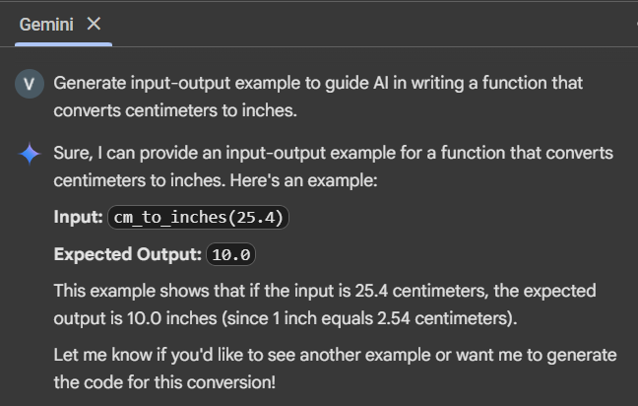

**CODE AND OUTPUT:**

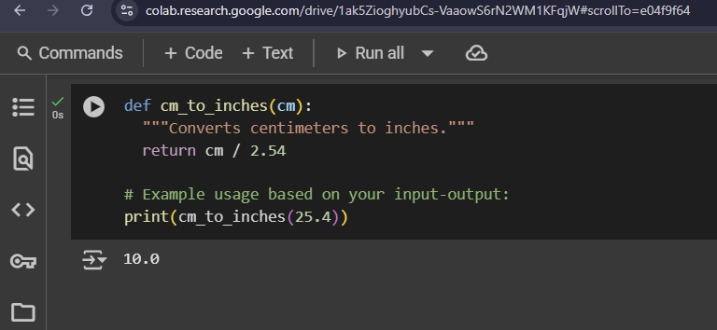

**Task Description#3**  
● Few-shot: Provide 2–3 examples to generate a function that formats full names as“Last, First”.

**Expected Output#3**  
● Well-structured function respecting the examples.

**PROMPT:**

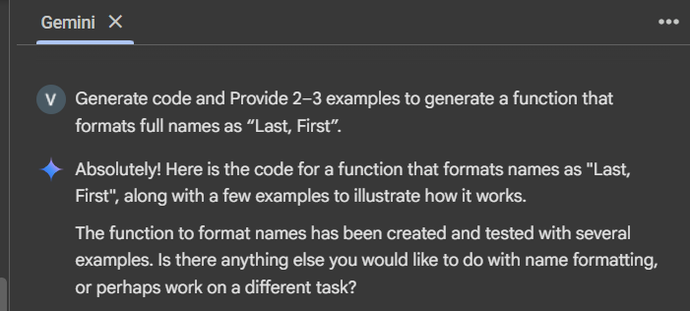

**CODE AND OUTPUT:**

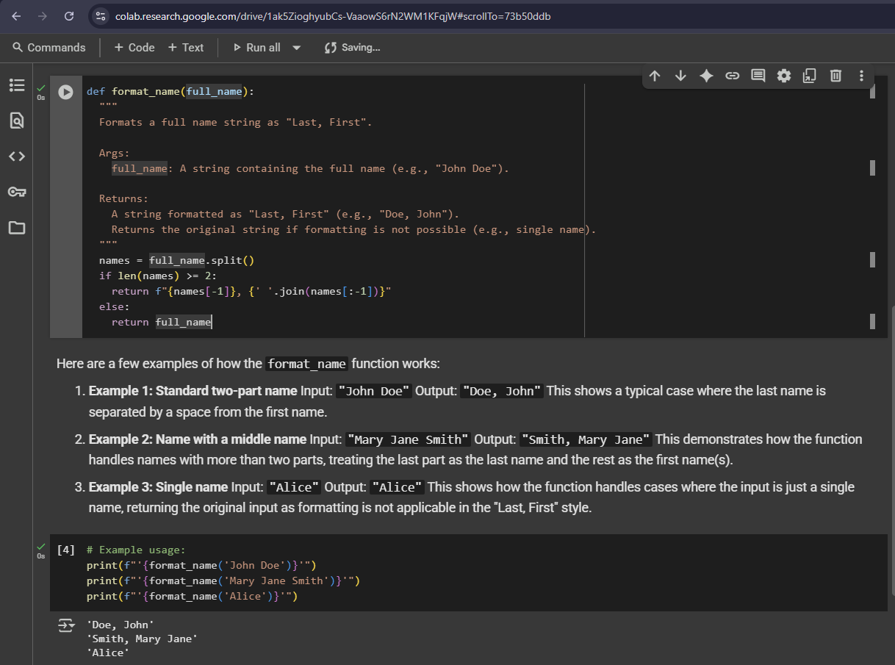

**Task Description#4**  
● Compare zero-shot and few-shot prompts for writing a function that counts the  
number of vowels in a string

.  
**Expected Output#4**  
● Functional output and comparative reflection.

**PROMPT:**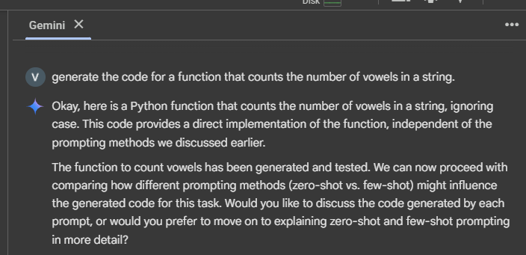

**CODE AND OUTPUT:**

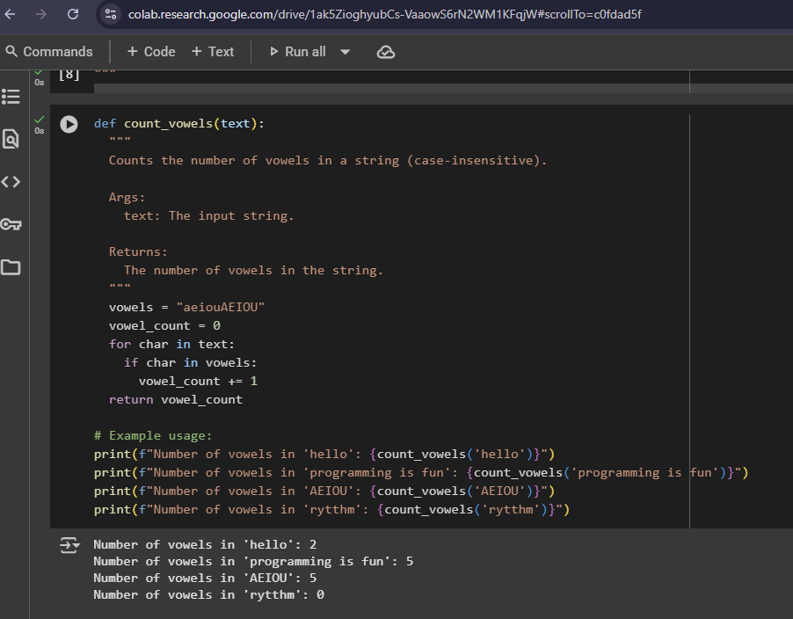

**Task Description#5**  
● Use few-shot prompting to generate a function that reads a .txt file and returns thenumber of lines.

**Expected Output#5**  
● Working file-processing function with AI-guided logic.

**PROMPT:**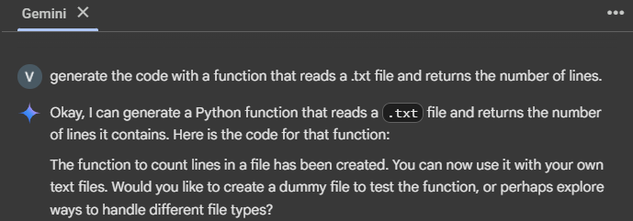

**CODE:**